# Measurable and Progress from maladaptive behaviors.

|  |  |  |  |  |  |
| --- | --- | --- | --- | --- | --- |
| Maladaptive Behaviors | Baseline Date:2017-09-23to2017-09-25 | Current average per week (3/31/2020) | % of Reduction(BL-average/ BL)*100 | Status | Updated STO (3/31/2020) |
| Self-Injurious behavior | 21 incidents per weeks | 13 incidents per week. | 40% | In progress | Sto1(MASTERED 2018-08-04). Sto2(MASTERED 2020-02-22). Currently: STO 3(Initiated 3/1/2020) |
| Physical Aggression | 28 incidents per weeks | 18 incidents per week. | 37% | In progress | Sto1(MASTERED 2018-05-19). Sto2(MASTERED 2018-11-24). Sto3(MASTERED 2020-01-11). Currently: STO 4(Initiated 2/1/2020) |
| Property destruction | 28 incidents per weeks | 16 incidents per week. | 41% | In progress | Sto1(MASTERED 2018-10-06). Sto2(MASTERED 2020-02-29). Currently: STO 3(Initiated 3/1/2020) |
| Tantrum | 42 incidents per weeks | 19 incidents per week. | 54% | In progress | Sto1(MASTERED 2018-01-20). Sto2(MASTERED 2018-05-19). Sto3(MASTERED 2018-08-11). Sto4(MASTERED 2018-11-03). Sto5(MASTERED 2020-03-20). Currently: STO 6(Initiated 4/1/2020) |
| Argumentative/Defiant behavior | 35 incidents per weeks | 16 incidents per week. | 53% | In progress | Sto1(MASTERED 2018-01-20). Sto2(MASTERED 2018-05-19). Sto3(MASTERED 2018-09-29). Sto4(MASTERED 2020-02-22). Currently: STO 5(Initiated 3/1/2020) |
| Disruption | 35 incidents per weeks | 16 incidents per week. | 54% | In progress | Sto1(MASTERED 2018-02-24). Sto2(MASTERED 2018-07-07). Sto3(MASTERED 2018-12-15). Sto4(MASTERED 2019-12-28). Currently: STO 5(Initiated 1/1/2020) |
| Task refusal | 56 incidents per weeks | 20 incidents per week. | 65% | In progress | Sto1(MASTERED 2018-01-20). Sto2(MASTERED 2018-01-20). Sto3(MASTERED 2018-05-19). Sto4(MASTERED 2018-08-11). Sto5(MASTERED 2018-11-03). Currently: STO 6(Initiated 12/1/2018) |
| Out of Sit Behavior | 56 incidents per weeks | 39 incidents per week. | 29% | In progress | Sto1(MASTERED 2020-03-14). Currently: STO 2(Initiated 4/1/2020) |
| Lying Behavior | 49 incidents per weeks | 39 incidents per week. | 19% | In progress | Sto1(MASTERED 2020-02-29). Currently: STO 2(Initiated 3/1/2020) |
| Stereotypes Behavior | 63 incidents per weeks | 42 incidents per week. | 32% | In progress | Sto1(MASTERED 2020-02-22). Currently: STO 2(Initiated 3/1/2020) |
| Total of Reduction (%) | - | - | - | - | 43.0483276644 |

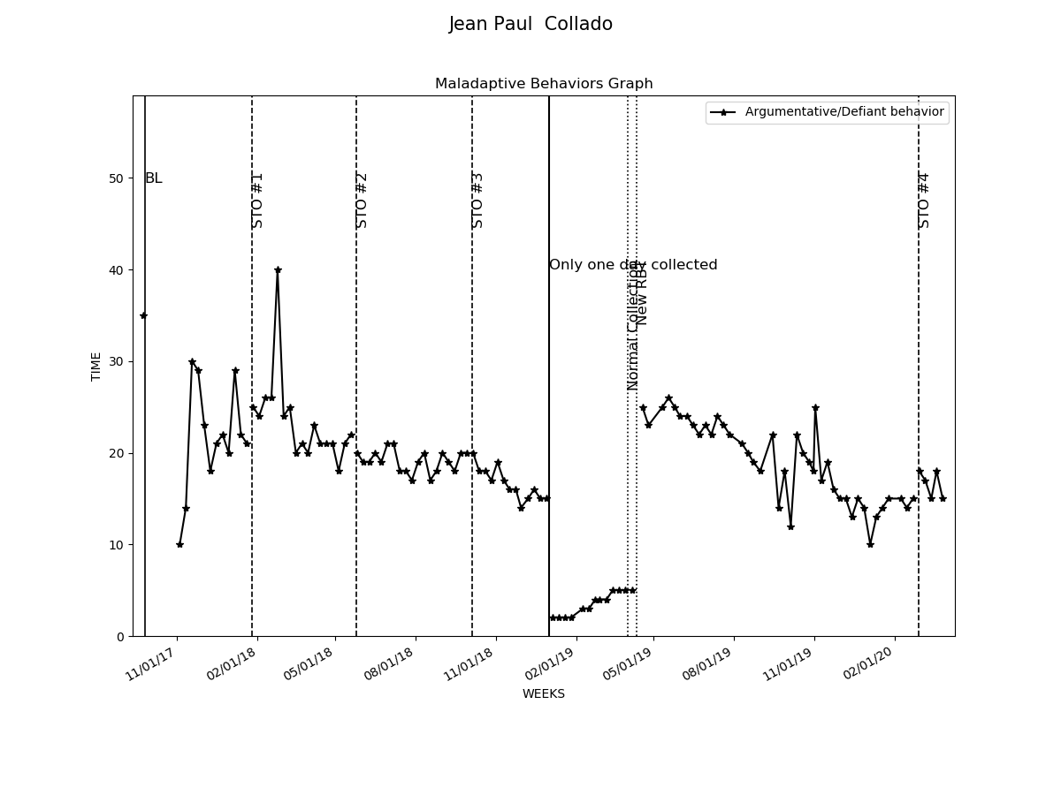

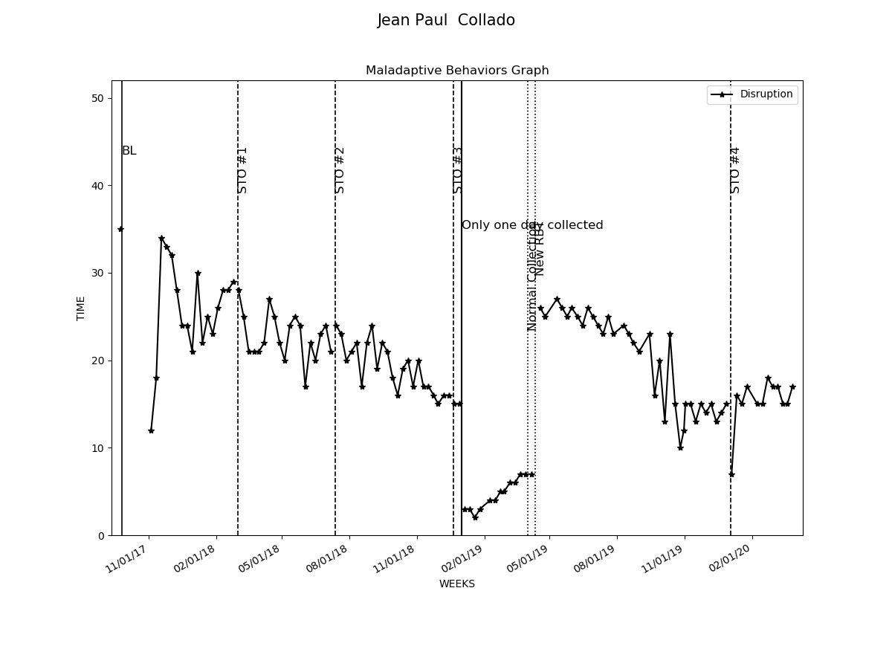

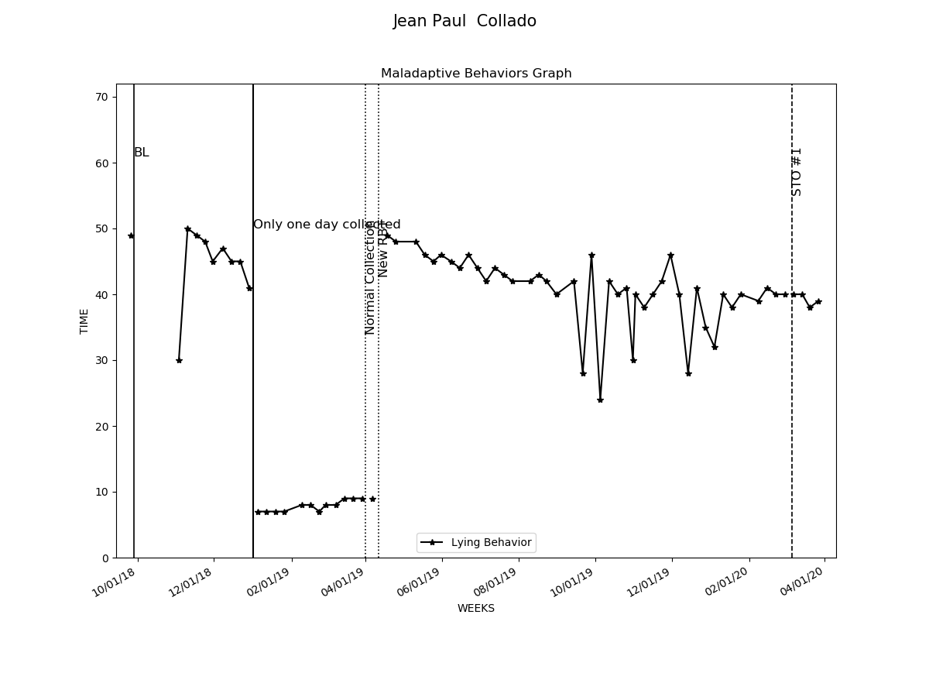

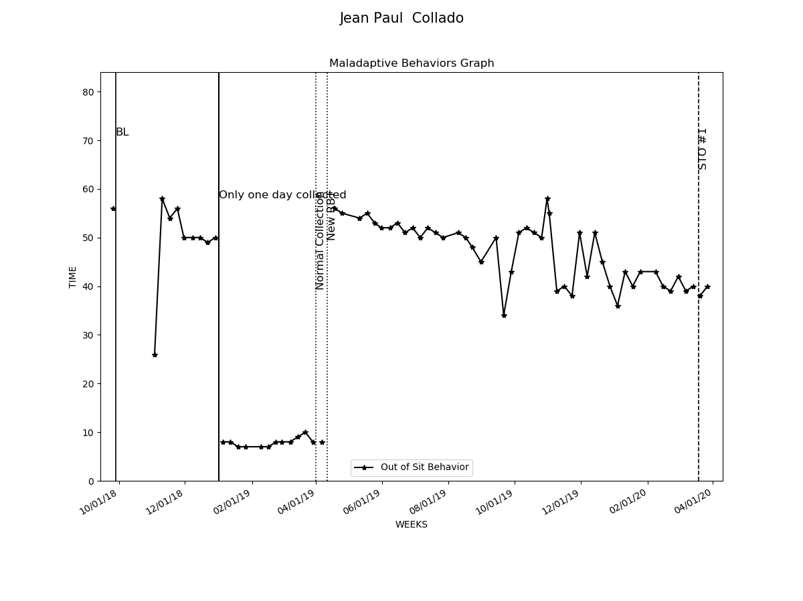

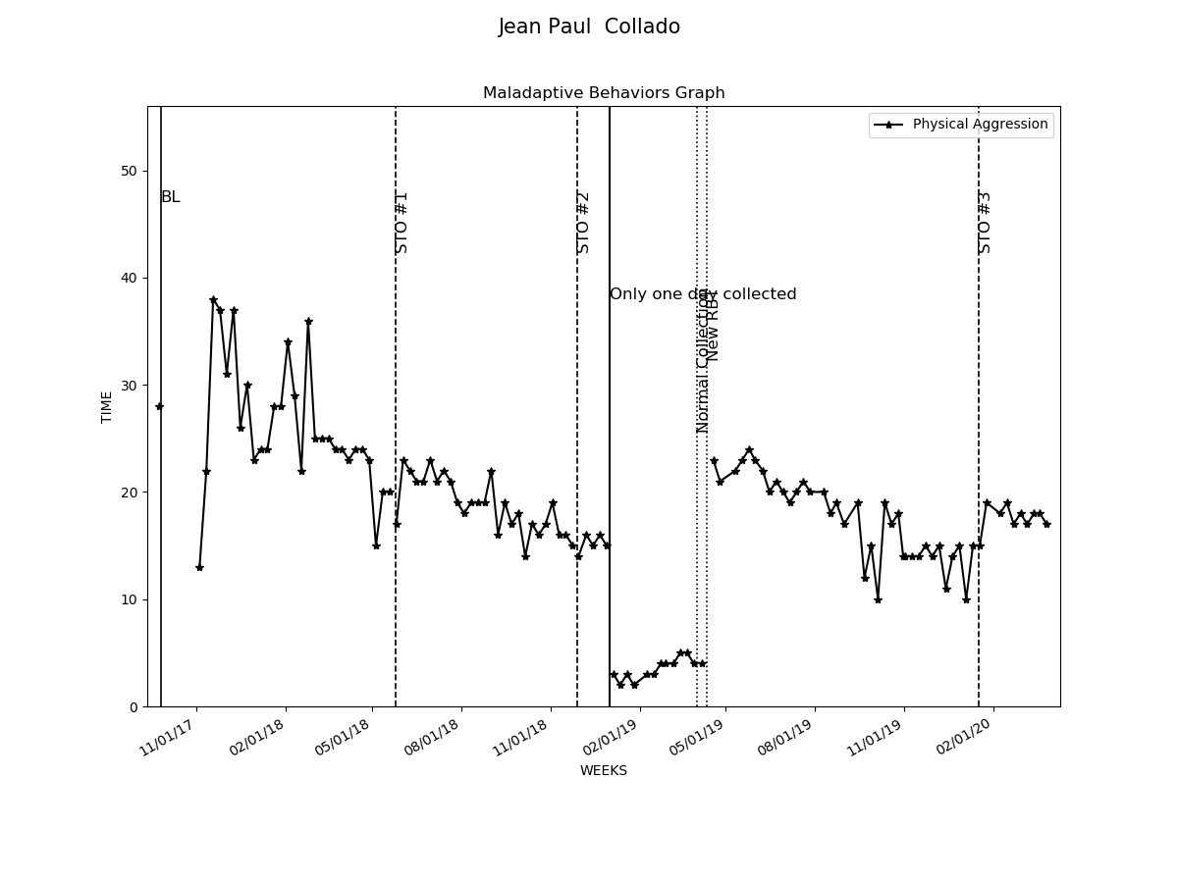

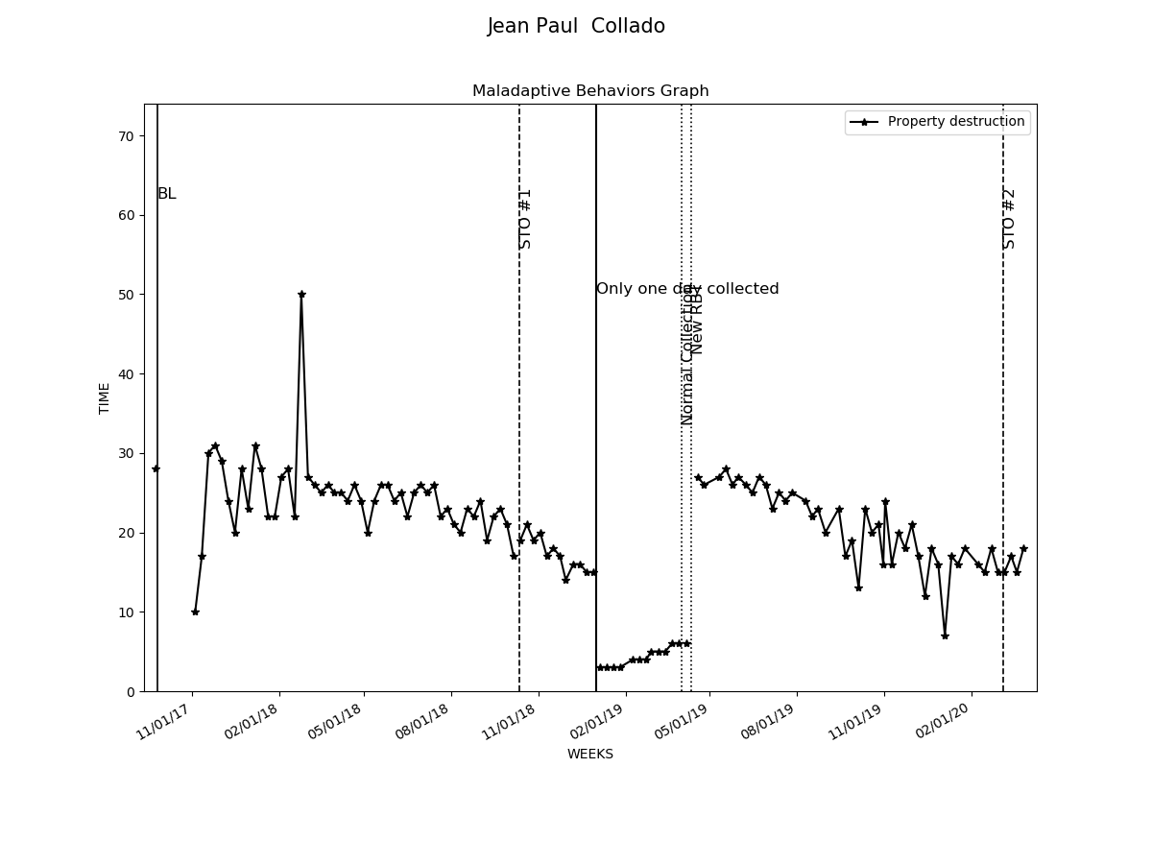

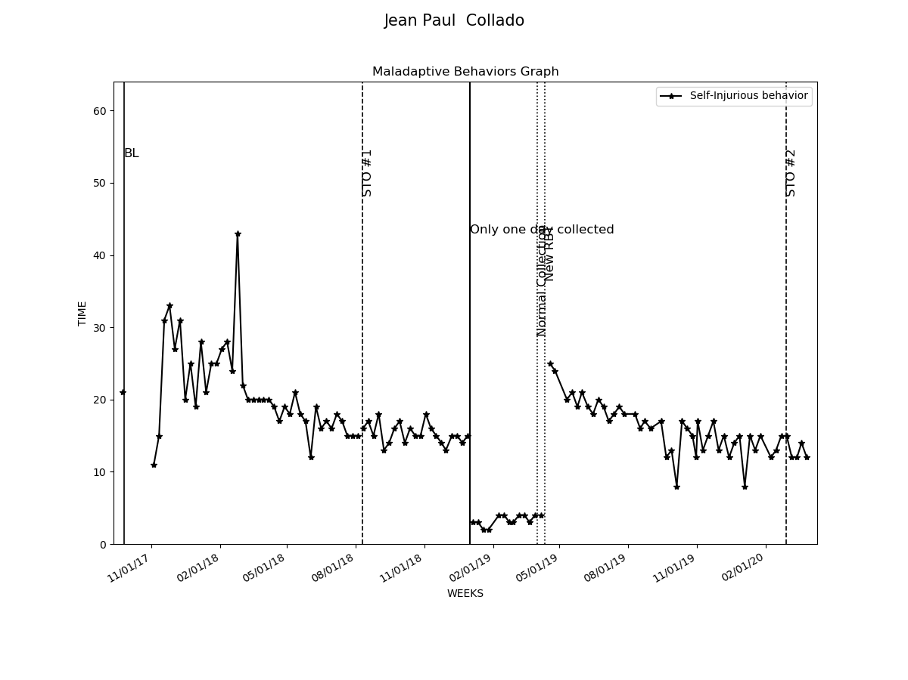

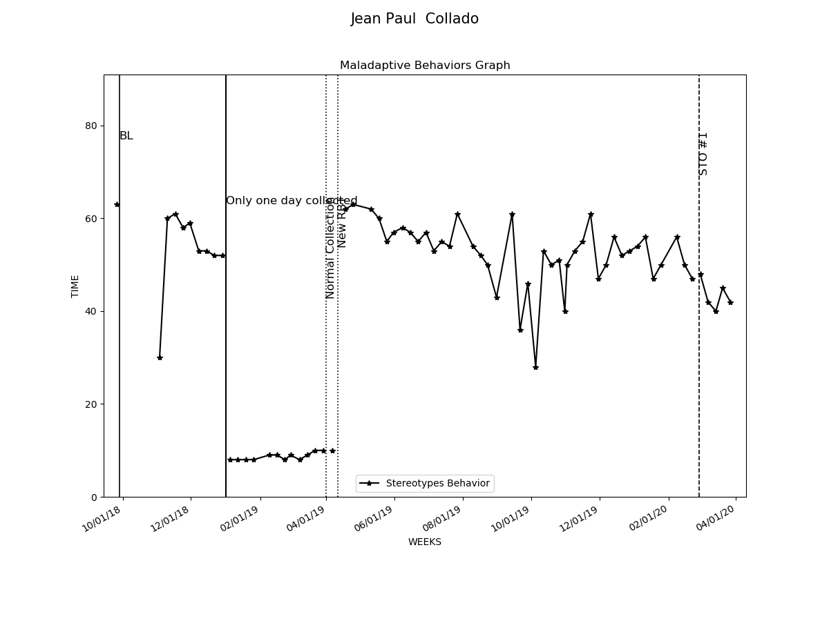

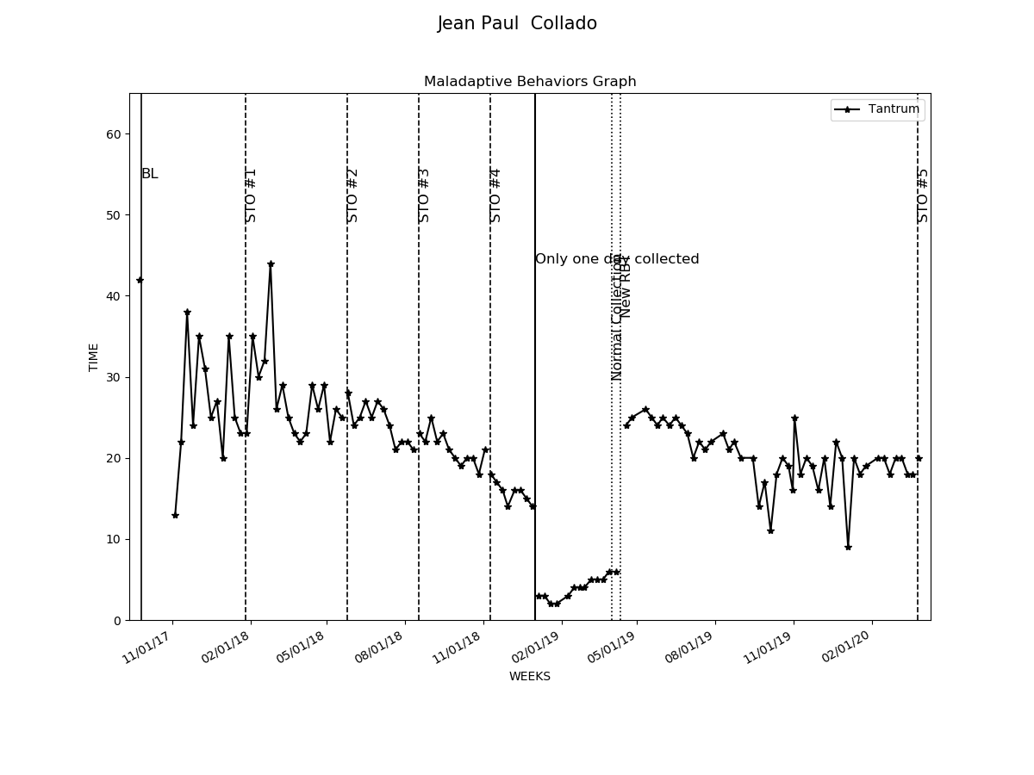

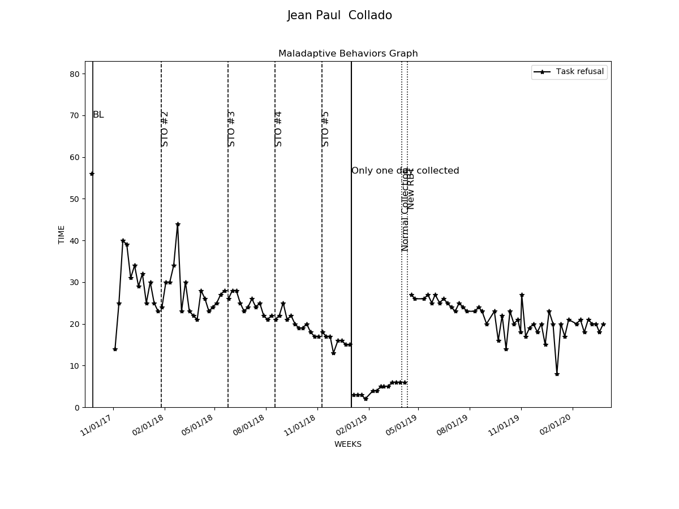

# Graphs Replacement and Interventions

|  |  |  |  |  |
| --- | --- | --- | --- | --- |
| Replacements and Programs | Baseline Date:2017-11-04to2017-11-07 | Current average per week (3/31/2020) | Status | Updated STO (3/31/2020) |
| 1- Request Break | 0% | 40% | In progress | Sto1(MASTERED 2018-09-01). Sto2(MASTERED 2020-01-18). Currently: STO 3(Initiated 2/1/2020) |
| 2- Request Attention | 0% | 39% | In progress | Sto1(MASTERED 2018-08-11). Sto2(MASTERED 2020-02-29). Currently: STO 3(Initiated 3/1/2020) |
| 3- Request Tangible | 3% | 39% | In progress | Sto1(MASTERED 2018-09-22). Sto2(MASTERED 2020-01-18). Currently: STO 3(Initiated 2/1/2020) |
| 4- Follow instructions | 3% | 39% | In progress | Sto1(MASTERED 2018-07-28). Sto2(MASTERED 2020-02-29). Currently: STO 3(Initiated 3/1/2020) |
| 5- Wait for Tangible | 3% | 41% | In progress | Sto1(MASTERED 2018-07-28). Sto2(MASTERED 2020-03-27). Currently: STO 3(Initiated 4/1/2020) |
| 6- Social Skills- Initiate and sustain interaction | 0% | 40% | In progress | Sto1(MASTERED 2018-03-31). Sto2(MASTERED 2019-11-09). Currently: STO 3(Initiated 12/1/2019) |
| 7- Social Skills- Taking turns during a play | 0% | 41% | In progress | Sto1(MASTERED 2018-03-31). Sto2(MASTERED 2019-11-23). Currently: STO 3(Initiated 12/1/2019) |
| 8- Social Skills- Ask for information | 3% | 42% | In progress | Sto1(MASTERED 2018-09-15). Sto2(MASTERED 2020-01-18). Currently: STO 3(Initiated 2/1/2020) |
| 9- Social Skills- Interrupt conversation | 0% | 39% | In progress | Sto1(MASTERED 2018-11-17). Sto2(MASTERED 2020-02-29). Currently: STO 3(Initiated 3/1/2020) |
| 10- Social Skills- Converse with other | 0% | 61% | In progress | Sto1(MASTERED 2018-03-24). Sto2(MASTERED 2018-09-29). Sto3(MASTERED 2020-03-20). Currently: STO 4(Initiated 4/1/2020) |
| 11- Stay on task | 0% | 92% | In progress | Sto1(MASTERED 2019-12-21). Sto2(MASTERED 2020-03-27). Currently: STO 3(Initiated 4/1/2020) |
| 12- Remain seated | 6% | 36% | In progress | Sto1(MASTERED 2018-11-17). Sto2(MASTERED 2020-02-15). Currently: STO 3(Initiated 3/1/2020) |
| 13- Working independently | 0% | 93% | In progress | Sto1(MASTERED 2020-02-29). Currently: STO 2(Initiated 3/1/2020) |
| 14- Brushing teeth | 6% | 40% | In progress | Sto1(MASTERED 2018-09-15). Sto2(MASTERED 2019-12-14). Currently: STO 3(Initiated 1/1/2020) |
| 15- Bathing | 3% | 40% | In progress | Sto1(MASTERED 2018-09-22). Sto2(MASTERED 2020-01-18). Currently: STO 3(Initiated 2/1/2020) |
| 16- Nigth time routine | 3% | 39% | In progress | Sto1(MASTERED 2018-11-17). Sto2(MASTERED 2019-12-28). Currently: STO 3(Initiated 1/1/2020) |
| 20- Parent Training - Data Collection | 0% | 48% | In progress | Sto1(MASTERED 2019-11-16). Sto2(MASTERED 2020-02-22). Currently: STO 3(Initiated 3/1/2020) |
| 21- Parent Training - Generalization of skills | 0% | 44% | In progress | Sto1(MASTERED 2019-11-16). Sto2(MASTERED 2020-03-14). Currently: STO 3(Initiated 4/1/2020) |

